All about me
Put a picture of me in this space
Hello, my name is:

All about me
My full name is:

I like to be called:

My date of birth is:

My home language or languages are:

What is my home country:

My religion, beliefs, culture are:

How often will I come here?

Which days of the week/what times:

My parent/s’ names are:

I have: brothers and: sisters
Their names are:

What other settings (Pre-school/ Nursery/Childminder) do I attend and how often:

I have had a 2-year progress check (yes or no):

If yes, when and by whom:

Who else cares for me (friends, family members):

I have a pet: called:

Meeting my needs
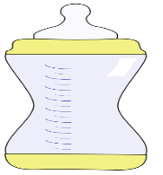 | Milk: Times  Amount  Warm or cold
My sleep routine is

Signs that I am sleepy

My comforter is
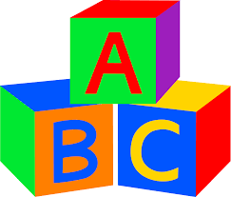 | My favourite toy is  Things I like to do at home
Things that make me sad or unhappy
Things I am not keen on doing
What helps me when I feel upset?
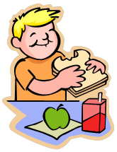 | Foods I like to eat at home  Foods I don’t like  Can I feed myself or do I need help
Am I in nappies?
Am I being toilet trained?
Do I prefer the toilet or the potty
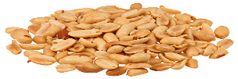 | Do I have any allergies?  If so what?
 | My favourite book, rhymes, songs, music are:
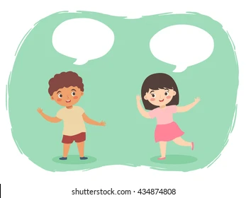 | My communication at home  How do I make my needs known?  Do I use words?  Which words have you heard me say at home?  Do I listen to instructions and follow them?
I need help with …

Anything else that is important about me?

